Technical Documentation for Complies EU Medical Device Regulation 2017/745

Contents
Introduction 1
Transition to the new legislation 1
Compiling the technical documentation 2
Content of the technical documentation 4
Conformity assessment –review of technical documentation 7
Person responsible for regulatory compliance 8
Requirements related to authorized representatives 8
Archiving periods for technical documentation 8
Summary – from the MDD/AIMDD to the MDR:
what changes with regard to technical documentation? 8

Key dates

On 26 May 2017, a new regulation entered into force, meaning that by 26 May 2020, for Manufacturers to obtain or renew a CE certificate or to issue a Declaration of Conformity (DoC), their technical documentation will need to comply with the Medical Device Regulation (MDR) European Union (EU) Regulation 2017/745 (referred to as ‘MDR’ hereafter)
.
However, as indicated in Article 120 of the MDR, after 26 May 2020, medical devices can still be placed on the market under the provision of the MDD/AIMDD, providing the certificate was issued prior to this date, that manufacturer continues to comply with either one of the directives and that no significant changes are made in the design and intended purpose of the device. Manufacturers of such devices must also meet other requirements, which are detailed in Article 120 of the MDR and referenced later in this white paper.
The certificates issued in accordance with MDD/AIMDD after 25 May 2017 remain valid until reaching their expiry date, but in any case, they become void latest on 27 May 2024.

This necessitates changes for the manufacturers on how the technical documentation should be developed and handled. As mentioned in the first paragraph from Annex II of the MDR, ‘the technical documentation shall include in particular the elements listed in this Annex’.

According to Article 10 of the MDR ‘technical documentation shall be such as to allow the conformity of the device with the requirements of this regulation to be assessed’.

the Global Harmonization Task Force (GHTF) has created the ‘Summary Technical Documentation (STED)’, intended to be a consistent, summarized or abridged form of the technical documentation, with sufficient detail to allow the NB to fulfil its obligations. The STED represents the status
of the medical device at a specific moment of its life cycle and should be updated to correspond to the technical documentation.
As a follow-up initiative, the International Medical Devices Regulators Forum (IMDRF) published a guidance document, providing an internationally harmonized format, in the form of a Table of Contents,1 that could be used in the future for the electronic submission of medical devices to a reviewing body for market authorization.

Transition to the new legislation

Manufacturers of class I devices, which are not provided sterile, have no measurement function and
are not reusable surgical instruments, will also need to update their technical documentation in order to comply with the regulation. . , even though they may issue a MDR compliant DoC without involvement of a NB.
This necessitates work from manufacturers to adopt the requirements of the MDR with regard to technical documentation, should they wish to keep their devices on the European market or introduce new devices. It also implies that manufacturers of devices, even those that have been on the market for many years, need to start collecting or complete review of existing Post-Market Surveillance (PMS) data, to be able to cover the requirements related to clinical evaluation, as set out by Article 61 of the MDR. Manufacturers need to implement all MDR PMS requirements with effect from 26 May 2020, even if the devices concerned are still being placed on the market under the MDD/AIMDD. Indeed, in Article 120.3 of the MDR it is clearly stipulated, that for manufacturers of devices with a certificate that was issued in accordance with the MDD/AIMDD, ‘the requirements of this regulation relating to post-market surveillance, market surveillance, vigilance, registration of economic operators and of devices shall apply in place of the corresponding requirements’ in the directives.

Compiling the technical documentation
Technical documentation has to be developed during the design and development process of a device and maintained throughout its entire life cycle. As illustrated in Figure 1, this process can be represented using the V-model, as it delivers documents and records, which form the Design History File (DHF).
Design reviews that approve or reject design inputs as well as ongoing results of the design and development process verify the status of documented results at certain points in the process. It is important to ensure that the requirements and solutions, which are adopted during a review for device improvement, are documented in the technical documentation (DHF, Device Master Record (DMR) and STED). The design Verification and Validation (V&V) of individual components, subassemblies, assemblies and the entire device provide the evidence of whether specifications have been met. If they have not, changes may need to be made to the specifications, by applying the design change control procedures of the implemented quality management system. The design outputs, which are
based on these changed specifications, undergo the same verifications, validations and finally design reviews. These are the basic principles of a design and development process and of a device V&V.
The technical documentation represents the entirety of the documents describing a device. It therefore includes the device’s design, development, V&V (including clinical and performance validation) as well as its regulatory status within target markets.
Furthermore, the MDR now requires a closed loop process, implemented with data from the
post-market use of the device (PMS), in order to ensure that early warnings are captured, that the ‘General Safety and Performance Requirements (GSPRs)’2 are continuously fulfilled and that the benefits for the patient always outweigh the risks.
The technical documentation should be structured and presented, in such a way, as to facilitate its review and assessment by the NB (Figure 2). This means that the compilation of technical documentation requires the application of quantitative and qualitative filters, allowing an adequate level of detail to be maintained, while avoiding the inclusion of superfluous details not necessary to demonstrate fulfilment of the GSPRs.
As illustrated in Figure 2, specific elements required by the NB for the review (e.g. cover letters etc.), as well as the elements from the Quality System (QS) required to demonstrate compliance, are also to be included in the technical documentation.
Post-market data is the final subset of documents to be included; for new devices this may consist
of, amongst other things, vigilance data from competitors and of the manufacturer’s plan for activities to be implemented once the device is on the market (such as a Post-Market Clinical Follow-up (PMCF) Study); for devices that have previously been placed on the market, this includes, but is not limited to the PMCF data, vigilance data, user feedback and complaints. Based on these post-market data, new inputs may trigger a novel cycle in the design and development process. This input may be implemented under design change controls, which are necessary to introduce corrective and preventive measures, in order to maintain the benefit-risk balance and to ensure continuous
fulfilment of the GSPRs.
A clear structure throughout the technical documentation is helpful in ensuring that the reviewing body can clearly understand the contents. Therefore, it is important for the manufacturer to maintain traceability from the User Requirements Specification (URS), to the Functional Requirements Specification (FRS), risk analysis, clinical evaluation and the general requirements for safety and performance, as well as the reverse (Figure 3) to ensure consistency of the evidence documents and records throughout the technical documentation. A URS can determine several FRSs
Each FRS may be involved in several hazards and associated risks. Each risk, identified through a risk analysis, may be linked to one or more questions to be treated by clinical evaluation and to one or more general requirements for safety and performance.
Keeping traceability of all of this within the manufacturer’s technical documentation, whilst challenging, is essential for demonstrating to CAs/NBs continuous fulfilment of the GSPRs.
When compiling technical documentation, manufacturers should ensure they take into account the MDR annexes,3 which determine the extent and detail by which the CAs/NBs will review the technical documentation, as determined by the MDR provisions.

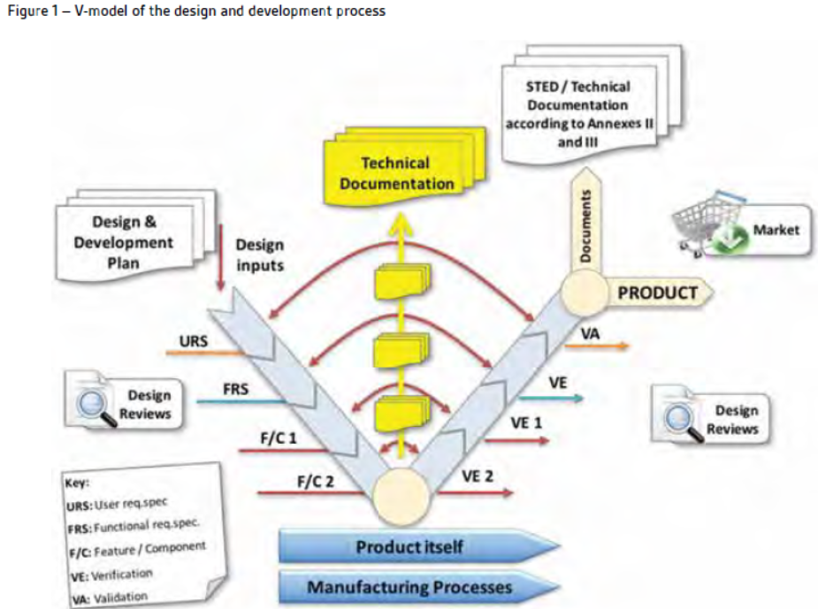

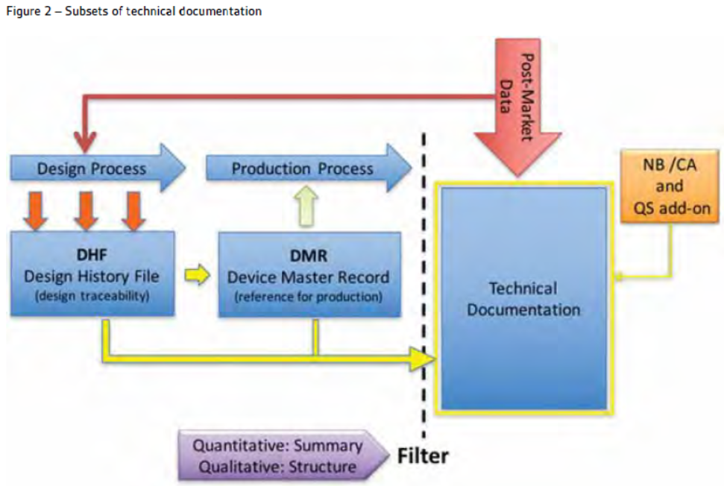

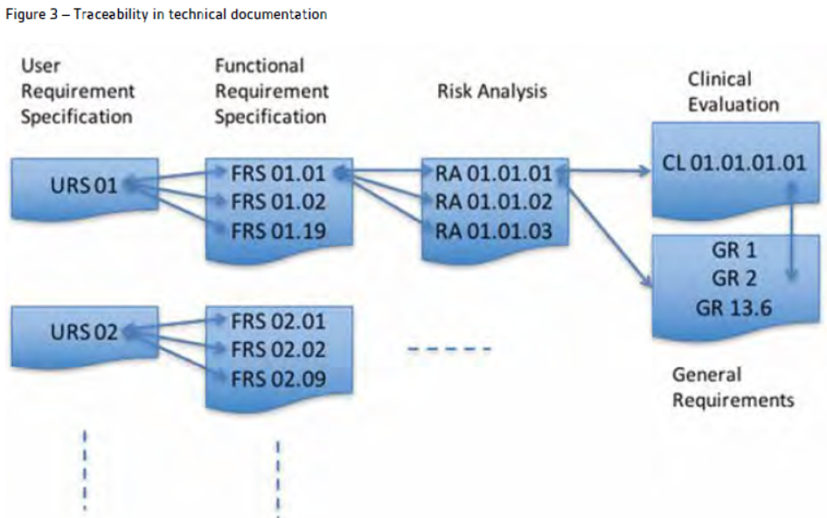

Content of the technical documentation
As with the MDD/AIMDD, the MDR outlines the minimum elements to be included within technical documentation. For medical devices, this information is stipulated in Annexes II and III of the MDR.
In the past, the list of required elements was not always specific and less exhaustive and manufacturers were required to determine and justify what was appropriate and sufficient to assure the compliance of their medical device with the relevant directive. Therefore, to complete their technical documentation, manufacturers often relied on the recommendations found in the document ‘NB-MED/2.5.1Rec5’ (Title of document: Technical Documentation / Chapter: 2.5.1 – Conformity assessment procedures; General rules) developed by the organization called ‘Coordination
of Notified Bodies Medical Devices (NB-MED), on council directives 90/385/EEC, 93/42/EEC and 98/79/EC’ and on the GHTF-STED document.
It is a declared objective of the MDR4 to take into account the GHTF and IMDRF guidance documents, in order to promote the global convergence of regulations. For technical documentation, this concerns the STED and IMDRF/ RPS WG/N9FINAL:2014 documents, respectively. Therefore, the MDR now provides, in Annexes II and III, detailed instructions on what is the minimum content of technical documentation, also defining a specific structure for it.
Manufacturers should use these annexes of the MDR to ensure their technical documentation complies with the new legislation.
Within this technical documentation, manufacturers must also provide suitable objective evidence to show that their device satisfies the requirements detailed in Annex I of the MDR GSPRs. Where manufacturers determine that specific GSPRs are not applicable to their device, ‘an explanation as to why [they] do not apply’, must be provided, which is a new requirement in the MDR (Annex II, point 4(a)).
Other technical documentation requirements introduced by the MDR are included in the following list:

- In the ‘device description and specification’ section, the manufacturers now need to make a reference to the basic Unique Device Identification-Device Identifier (UDI-DI), as soon as identification of the device becomes based on a UDI system (Annex II, point 1.1.1(b)). Furthermore, as part of the technical documentation, manufacturers shall also keep an up-to-date list, containing all UDIs they have assigned (Article 27, point 7). The UDI system will also have a direct impact on the labelling, artwork and DoC, as manufacturers will need to place a UDI carrier on the label of the device and on all higher levels of packaging, except the shipment packaging (Article 27, point 4). Specific transition periods for this requirement are determined in Article 123(f).

- In the case of reusable surgical instruments the MDR requires that the UDI is placed on the instrument in such a way as to be readable after each procedure that is performed to ready the device for the next use (Annex VI, part C, point 4.10).

- Article 18 of the MDR stipulates that manufacturers of implantable devices (with the exception of sutures, staples, dental filings, dental braces, tooth crowns, screws, wedges, plates, wires, pins, clips and connectors) shall provide an ‘implant card’ with their devices. This implant card shall contain ‘information allowing the identification of the device, including the device name, serial number, lot number, the UDI, the device model, as well as the name, address and website of the manufacturer’. The implant card represents part of the labelling that needs to be integrated into the technical documentation.

- For manufacturers of Single Use Devices (SUDs), the technical documentation, specifically the risk management documentation, shall, according to the GSPRs, demonstrate and substantiate why the device is manufactured as a SUD (Annex I, chapter III, point 23.4(p)). As a measure of precaution and to clarify the technical challenge for any reprocessing attempt, it should clearly be stipulated why the device cannot be reprocessed. According to the authors, for most SUDs on the market today, evidence of the technical and scientific substantiation for the designation as a SUD is lacking in the technical documentation.

- The manufacturers shall define the risk class of the device and provide the justifications for the classification rule(s) applied (Annex II, point 1.1.1(f)). Though classification of the device was already required by the MDD/AIMDD, the MDR introduces new classification rules. Some devices have changed risk class and manufacturers should therefore verify whether their medical device is affected by these changes or not. The technical documentation will require an update with regard to classification, rationales and rules to reflect the MDR requirements, as stipulated in Annex VIII.

- An entire subsection of the technical documentation is now to be dedicated to referencing previous and similar generations of the device (Annex II, point 1.2). Where applicable, manufacturers shall give an overview of the previous generation or generations of their device(s) and also identify and describe similar devices available on European or international markets. Those devices shall be taken into account in the clinical evaluation and its updates in the course of post-market activities.5

- For all classes of medical devices, manufacturers must now provide, as per Annex II, information in the technical documentation to explain the design stages and procedures that applied to their device (Annex II, point 3). Under the requirements of the MDD/AIMDD, this was only the case for class III devices. Therefore, depending on the classification of the device, manufacturers may need to update the content of the technical documentation.

- In accordance with the MDR, technical documentation shall contain information to demonstrate conformity with the GSPRs (Annex II, point 4). In comparison, the AIMDD/MDD, with further guidance from NB-MED/2.5.1Rec5, required manufacturers to ‘demonstrate how each of the applicable essential requirements and any derived technical requirements/specifications for the particular devices(s) concerned has been met’. Whilst the general aim has not changed manufacturers should pay particular attention to the fact that the MDR updates and extends the previous requirements necessitating the technical documentation be adapted. This should be achieved through the detailed review of the GSPRs and the enacting parts of the MDR to ensure that the technical documentation addresses the requirements and provides the required evidence of compliance.

- Under the MDR, the CA may request all information and documentation necessary to demonstrate the conformity of a device, to be provided in an official EU language, as determined by the EU member state concerned (Article 10, point 14). According to the MDD/AIMDD and the guidance NB-MED/2.5.1Rec5, the CA could request presentation of only the first part of the technical documentation in its official language. Furthermore, the CA was only supposed to do so, if the documentation or its content was not understandable in the other official EU language.

- Under the MDD/AIMDD, PMS activities were required under the various conformity assessment annexes, and manufacturers needed to establish a PMCF plan if following the conformity assessment route detailed in MDD Annex II/AIMDD Annex 2, and to supply upon request, results of this to the CA/NB. It was previously not obligatory to provide this information within the technical documentation, but this is now necessary following the implementation of the MDR Annex III.
- The MDR further defines the closed loops needed with regard to the flow of information required in a QS, including the technical documentation. The ‘Recitals6’ of the MDR clearly state that

‘manufacturers should play an active role during the post-market phase by systematically and
actively gathering information from post-market experience with their devices in order to update
their technical documentation and cooperate with the national CA in charge of vigilance and
market surveillance activities. To this end, manufacturers should establish a comprehensive postmarket surveillance system, set up under their quality management system and based on a PMS
plan. Relevant data and information gathered through PMS, as well as lessons learned from any
implemented preventive and/or corrective actions, should be used to update any relevant part of
the technical documentation, such as those relating to risk assessment and clinical evaluation, and
should also serve the purpose of transparency’.

Therefore, the MDR now requires a subpart within the technical documentation, which specifically addresses the PMS activities set up by the manufacturer. Details on what information needs to be provided in this part of the technical documentation are found under Annex III of the MDR. More precisely, the technical documentation now must contain a PMS plan that complies with the obligations of the manufacturers as referred to in Article 84 of the MDR, a Periodic Safety Update Report (PSUR) for devices greater than class I (Article 86 of MDR), or a PMS report for devices of class I (Article 85 of the MDR).
In summary, manufacturers of device(s) shall draw up the required technical documentation to include the elements set out in Annexes II and III of the MDR (Table 1), and continuously ensure it is up to date. The annexes, and their content, are referenced in the articles of the enacting part of the MDR, and are therefore an important part of the document. Manufacturers should also be aware that the European Commission is empowered to adopt delegated acts, which amend, in light of technical progress, these two annexes

.
Table 1 – Content of technical documentation as outlined in Annexes II (a) and III (b) of the MDR

Required Content of Technical Documentation as per MDR

(a) Annex II – Technical Documentation:

1. Device description and specification, including variants and accessories
1.1 Device description and specification

1.2 Reference to previous and similar generations of the device

2. Information to be supplied by the manufacturer

3. Design and manufacturing information

4. General safety and performance requirements

5. Benefit–risk analysis and risk management

6. Product verification and validation

6.1 Pre-clinical and clinical data

6.2 Additional information required in specific cases

(b) Annex III – Technical Documentation on Post Market Surveillance:

1. The post-market surveillance plan

2. The PSUR (Periodic Safety Update Report)

3. PMS Report

Conformity assessment –review of technical documentation
In all conformity assessment procedures involving a NB, a review of the technical documentation is mandatory.
Article 52 of the MDR provides details on the conformity assessment procedures, which are further set out in Annexes IX–XI, depending on the device. The sampling rate applied during audit by your NB is dependent upon the device classification, as detailed in the following list.
• Class III devices: Assessment of the technical documentation for every device
• Class IIb implantable devices (except sutures, staples, dental filings, dental braces, tooth crowns, screws, wedges, plates, wires, pins, clips and connectors) and class IIb active devices intended to administer and/or remove a medicinal product: Assessment of the technical documentation for every device
• All other class IIb devices: Assessment of the technical documentation for at least one representative device per generic device group
• Class IIa devices: Assessment of the technical documentation for at least one representative device for each category of devices
• Class I devices which are placed on the market in sterile condition, have a measuring function or are reusable surgical instruments: Assessment of the technical documentation relating only to those specific features of the device, e.g. sterility, measurement or reprocessing
For class I devices, which are not provided sterile, have no measurement function and are not reusable surgical instruments, NBs are not involved in conformity assessment. For such devices, manufacturers shall ‘declare the conformity of their products, by issuing the EU declaration of conformity referred to in Article 19 after drawing up the technical documentation set out in Annexes II and III’ (Article 52, point 7).

NBs are required to take a risk-based approach and must ensure that the technical documentation of all devices has been sampled over the validity period of the granted certificates.

Person responsible for regulatory compliance

Article 15 of the MDR clearly stipulates that it is an obligation for medical device manufacturers to have available, within their organization (or permanently and continuously at their disposal for micro and small companies), at least one person, possessing the necessary expertise in the field of medical devices, who is responsible for regulatory compliance. If within a company the responsibility for regulatory compliance is divided between several people, the respective roles and tasks of each single person must be clearly defined in writing. Among other responsibilities, the person or people responsible for regulatory compliance must ensure that the technical documentation is compiled
and maintained.
Micro enterprises (<10 employees and turnover <€2m) and small enterprises (<50 employees and turnover <€10m)7 are not required to have the person responsible for regulatory compliance within their organization, but shall have such a person permanently and continuously at their disposal.

Requirements related to authorized representatives
As per Article 11, ‘where the manufacturer of a device is not established in a Member State, the device may only be placed on the Union market if the manufacturer designates a sole authorized representative’. Manufacturers from outside the EU/European Economic Area (EEA) shall enable the legal representative to keep available amongst other documents, a copy of the technical documentation, therewith ensuring the effectiveness of their communication with and their obligations towards CAs/NBs. It is the task of the authorized representative to ‘verify that the EU declaration
of conformity and technical documentation have been drawn up and, where applicable, that an appropriate conformity assessment procedure has been carried out by the manufacturer’ (Article 11, point 3(a)).

Archiving periods for technical documentation
Technical documentation should be stored safely, protected from unauthorized access and alteration. Under the legislation of the MDD/AIMDD, manufacturers were obliged to keep technical ocumentation available for CAs for a period of at least 5 years (15 years for implants) after the last device has been placed on the market.
Under the MDR, manufacturers now need to keep the documentation available to CAs for 10 years (in line with 85/347/EEC)8 after the last device has been placed on the market. In the case of implantable devices, this minimum period is unchanged and stays at 15 years.
In the case of manufacturers whose place of business is outside the EU (+ EEA, Switzerland, Turkey) the authorized representative must share this obligation meaning they need to have a full and up-to-date copy of the technical documentation available for CA consultation for the same periods as manufacturers (Annex IX, chapter III, point 7).

Summary – from the MDD/AIMDD to the MDR: what changes with regard to technical documentation?
In general, the change from the MDD/AIMDD to the MDR requires some fairly significant adjustments by manufacturers with regard to a device’s technical documentation. The total number of documents to be included into the technical documentation remains broadly the same, the only difference being the inclusion of a PMS plan and a PSUR or a PMS report, as required by Annex III of the MDR. The expected quality of the technical documentation has however increased, especially when it comes to clinical data, which will need to be robust enough to duly substantiate any claims. Manufacturers will need to improve the scientific quality and intelligibility of their technical documentation.

Table 2 – Checklist for manufacturers: how to adapt technical documentation in order to comply with the MDR

Ensure that the medical device meets the general safety and performance requirements as set out in Annex I of the MDR and verify that the technical documentation addresses the new requirements and provides the requisite evidence of compliance

Verify whether the concerned medical device is affected by the change in classification and if necessary, update the technical documentation accordingly

For devices already on the market, start the necessary work to prepare a sound clinical evaluation to comply with the MDR requirements for clinical data to obtain a robust substantiation of any claim made. If not already underway, commence collecting, in a planned manner, PMS data for the devices to be used as input to this evaluation. Meddev 2.7.1 rev 4 can serve as a guidance on the methodology how clinical evaluation could be documented

Ensure that the technical documentation provides all necessary information, as defined by Annexes II and III of the MDR, and that the given structure has been adopted

Whenever UDI system becomes applicable, assign a UDI to the medical device in accordance with Article 27 of the MDR, and implement all the necessary labelling with the UDI

Designate a person responsible for regulatory compliance and who makes sure that the technical documentation is always up-to-date

Ensure that a controlled copy of the technical documentation is always available to the authorized representative (for manufacturers that are not based within the EU)

